PTE Reading:
Total mark allocation from different modules from Writing, reading and listening
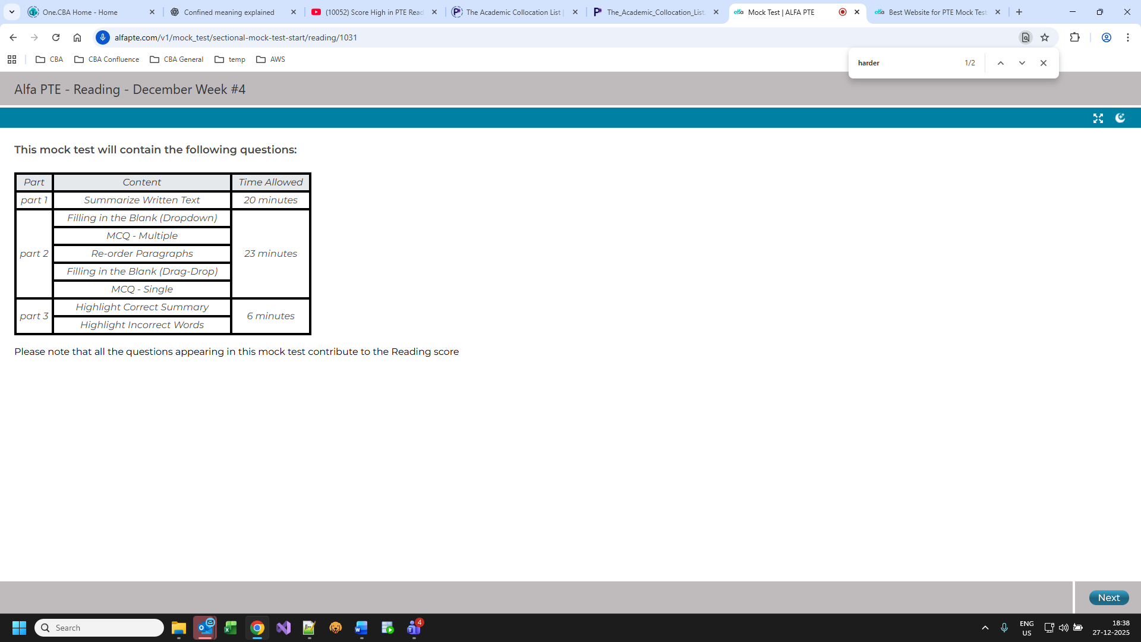
Max 23 to 27 mins for reading module which is reduced from 33 mins for academic for i.e part 2 above
Notes:
Gain full mark in
- Summarise written text:
- just follow While s1, s2; s3, and s4 rule and check written sentence by comparing the question at the end.
- Avoid brackets and question mark or !
- Highlight incorrect words:
- Listen the audio carefully
- Has negative marking so don’t select if not sure

-less than 2 min per fil in the blanks drag and drop and drop down so read it once
-Use collocation, grammar and context.

Before verb mostly adverb
- Adverb usually ends with ly

- After Start words mostly go with ing
Eg : start spinning

- Study collocation --------‘with’ , ------- ‘from’
With :
- Involved with
- Allied with
- Associated with
- Connected with or to
- Linked to or with
- Conflict with
- Contact with
- Deal with
- Correlated with
- Concerned with
From:
Cause / Origin
- stem from (originate from)
- result from
- arise from
- originate from
- come from
🔹 Separation / Removal
- protect from
- prevent from
- recover from
- escape from
- suffer from
🔹 Difference / Contrast
- different from
- distinguish from
- vary from
🔹 Distance / Range
- range from … to …
- far from
🔹 Avoidance / Defense
- deter from
- discourage from
- abstain from
🔹 Learning / Benefit
- learn from
- benefit from
- gain from

- After apostrophe ‘ noun will come
Eg snake’s strikes
- After may also , would, shall , should , could after this should be V1

Confined means – restricted or limited
Subdued means - quiet, restrained, or less intense than usual.
Stem or stemming – to prevent something from continuing or spreading or
to originate from, arise from, or be caused by something.
Nascent - just beginning to exist or develop; in the early stage.
Staple – everyday eaten food
Converging - coming together toward one point, becoming similar, or moving in the same direction.

Culpability - being responsible for a fault, mistake, or wrongdoing — especially in legal or accident-related situations.
Eg: The investigation determined the driver’s culpability in the accident.
Prosecution - the legal process of charging and trying someone in court for a crime
Examples:
- The prosecution presented strong evidence in court.
- He faces prosecution for fraud.
Absurd - completely unreasonable, illogical, or ridiculous.
Example:
The idea sounds absurd.
Razed - completely destroyed or torn down to the ground, usually referring to buildings, towns, or structures.
Example:
The old building was razed to make way for a new mall.

Mostly
Despite comes with noun / proun -ing or verb-ing
Despite being tired, he went to school
Despite having little time, she helped me

Although:
subject + verb (a clause)
Although she had little time, she helped me.
Although he is tired, he continues to work.

Collocations:
Ward off - to prevent something harmful or unwanted from happening or coming closer
Eg : She took medicine to ward off a cold.
Draw out – take out
Strong medium
Taken in – absorb
health benefits
thrive in -to grow, develop, or do very well in a particular environment or situation.
- • thrive in an environment
- • thrive in difficult conditions
- • thrive in a competitive market
Led to –
Turning point
Cut in – interrupt while speaking
Eg : Sorry to cut in, but I need to add something.
Torn down –
Cottoned on (to) - suddenly understood, realized, or became aware of something
Eg:
She finally cottoned on to what was happening.

Collocation from PTE site:
https://www.pearsonpte.com/ctf-assets/yqwtwibiobs4/1zeZPbVpJBNT9AXzPIefYy/0464e0617264f9c80bd3eab21d2877f7/The_Academic_Collocation_List.pdf

